Existing V2X and V2V technologies

Govcomm


govcomm.us

Overview
Govcomm is revolutionizing vehicles to infrastructure communications and increasing efficiency in transportation. By using Artificial Intelligence their programs allow traffic infrastructure to adapt to the situation and daily traffic loads. This allows for more efficient signaling which leads to less emissions from idle vehicles, improved speed of transportation and even use in emergency situations such as clearing the road for emergency vehicles.
Method:
“Improved Detection through IP Networking”
- Doesn't seem to use Vehicle to Infrastructure communication
- Could contact for questions
  - How much is security a concern in these systems and what methods are already in place?
  - For their system does traffic load scale well with their program (ie how is runtime affected)
- Proof that use case of our research can improve efficiency if implemented
  - Possibly ask about data on efficiency/ time/ emissions improvements with the govcomm system.

Autotalks

https://auto-talks.com/
Overview
Autotalks goes over the emerging Vehicle to Infrastructure (V2I) technology that is beginning to be implemented around the world. This includes “Thousands of Road Side Units (RSUs) equipped with V2X chipsets are spread across the US, Europe and Asia”. Autotalks has the goal of creating a single platform that can facilitate connection between vehicles and infrastructure. It also mentions the possible benefits including allowing faster travel of emergency vehicles, intersections capable of detecting pedestrians and sending this information to surrounding vehicles, and prioritizing public transportation. It also takes note that V2I programs will be required to have functional systems of autonomously driving vehicles as they become closer to reality on our roads.
V2X 350 Chip:
This chip is a product by autotalks which enables using any V2X technology. One benefit of the product is it allows for communication between vehicles and sending and receiving information between vehicles allowing for better communication and accuracy in vehicles. This product also has its own security system called the Hardware Security Module or ”eHSM”. This product also allows for implementing auto-breaking as well as “cost optimization”
Possible questions:
-could ask company about the cost optimization
-could investigate the methods used for vehicle security mentioned

Walkie-Talkie Project
https://journals.sagepub.com/doi/10.1155/2013/676850
Sage journals has a paper titled “Comprehensive Vehicular Networking Platform for V2I and V2V Communications within the Walkie-Talkie Project” which could relate to this research. The Walkie-Talkie project explores advanced wireless communication systems for intelligent transportation systems (ITS), focusing on vehicle-to-vehicle (V2V) and vehicle-to-infrastructure (V2I) communications. Their goal is to create a safer, smarter, and more efficient transport system where vehicles operate as nodes in a global communication network.
Key Terms:
-gateway (GW)
-mobile router (MR)

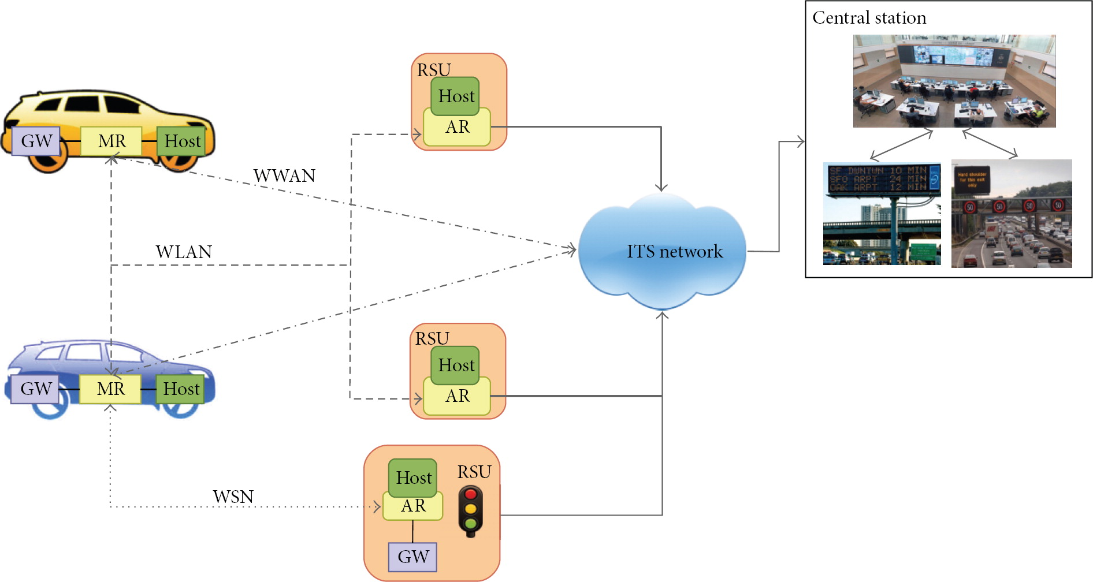
(Network Design as outlined by the paper above)
The paper also delves into much greater detail on the structure of the system.
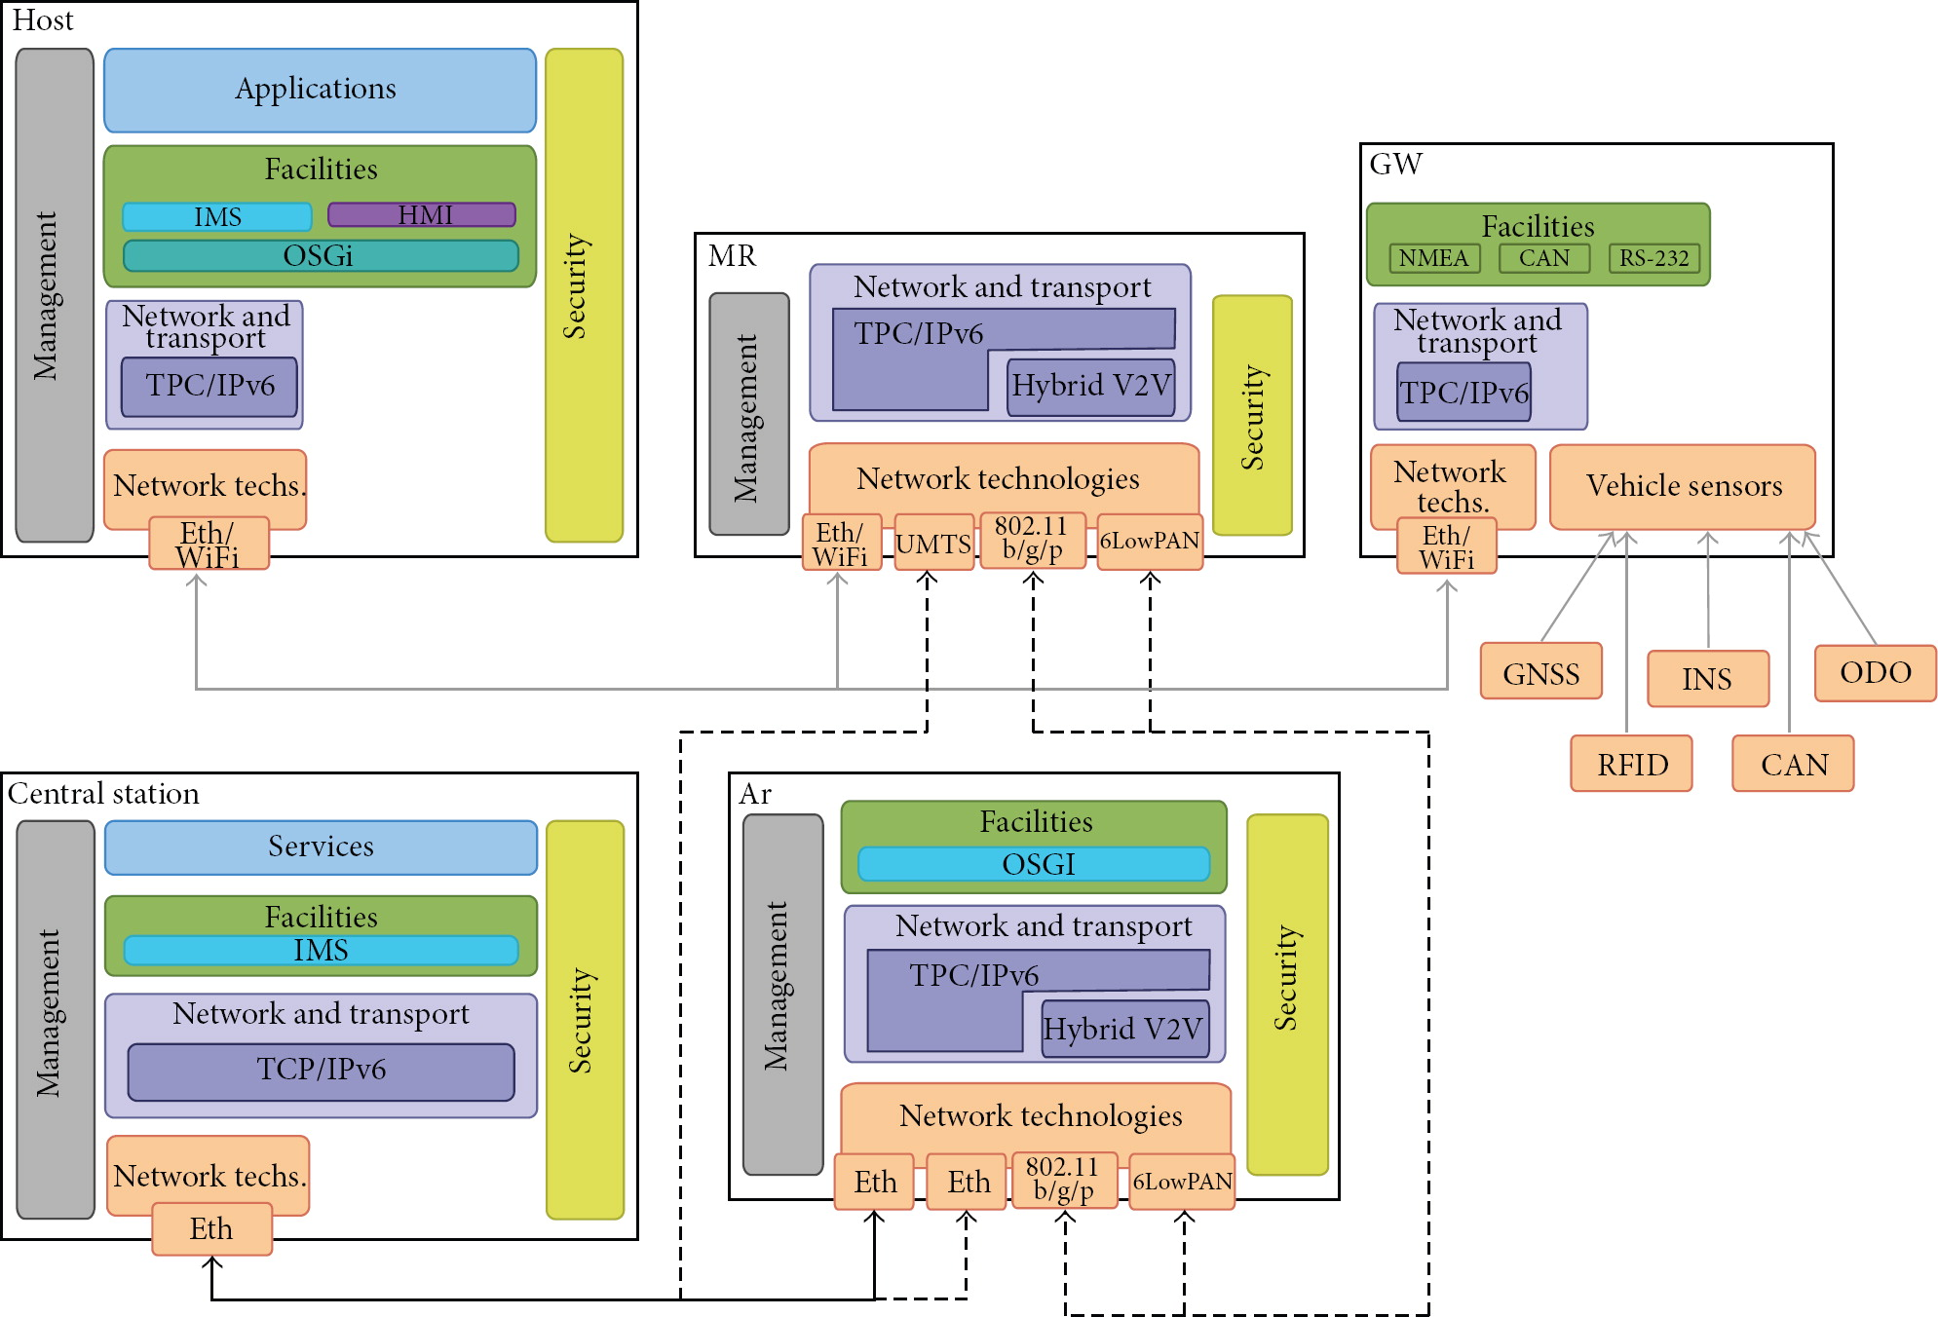

Range and Specs of Networking Hardware and Speeds

IEEE 802.11p WAVE Devices:
https://www.rfwireless-world.com/tutorials/ieee-802-11p-wave-dsrc-tutorial

IEEE 802.11p, also known as WAVE (Wireless Access for Vehicular Environments) or DSRC (Dedicated Short Range Communication) was created with the goal of creating more efficient travel by enabling communication both between vehicles as well as between vehicles and infrastructure.
*Note*“The FCC has allocated a 75 MHz bandwidth spectrum, ranging from 5850 to 5925 MHz, specifically for vehicle-to-vehicle and vehicle-to-infrastructure communication”
- Operates in the 5.9 GHz band.
- Bandwidth: Supports a 10 MHz bandwidth, compared to the 20 MHz used in 802.11a.
- Bit Rates: Supports half the bit rates of 802.11a: 3, 4.5, 6, 9, 12, 18, 24, and 27 Mbps.
- Modulation: Retains the same modulation schemes as 802.11a: BPSK, QPSK, 16QAM, and 64QAM.
- Data Carriers: Uses 52 data carriers per symbol, the same as 802.11a.
- Symbol Duration: Doubles the symbol duration compared to 802.11a, using 8 µs instead of 4 µs.
- Guard Interval: Employs a guard time interval of 1.6 µs, while 802.11a uses 0.8 µs.

C-V2X VEHICLE-ROAD-CLOUD PRODUCTS


https://www.cidi.ai/html/web/yingwen/V2XCITS/HARDWARE2PRODUCTS/index.html

Intelligent traffic sensing edge computing units:

TPCU:
Processor: 8core ARM v8.2 64-bit
AI compute power: 32TOPS
Memory: 32GB
Store: 32GB
Port: USB2.0x2,Gigabit Ethernet
Gigabit Ethernet: -25℃~+65℃
Power dissipation: < 60W
size: 142mm(L) x 110mm(W) x 66mm(H)

TPCU 2.0
Processor: 8core A78
AI compute power: 200TOPS/275TOPS
Memory: 32GB/64GB
Store: 64GB+128GB
Port:USB3.0x2、Gigabit Ethernet x4、RS422、RS232、CAN
Operating temperature: -25℃~+75℃
Power dissipation: < 60W
size: 207mm(L)x135mm(W)x59mm(H)

Vehicle Products:

OBU3.0
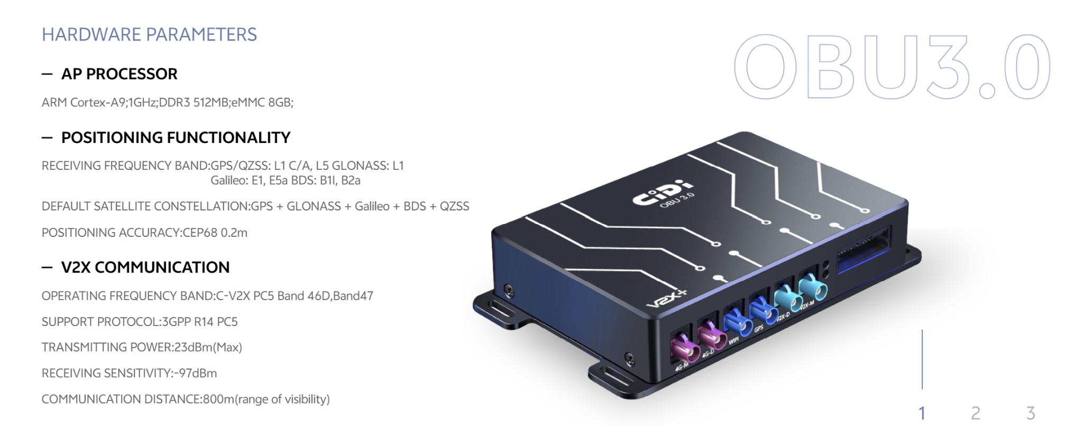

OBU3.0-5G
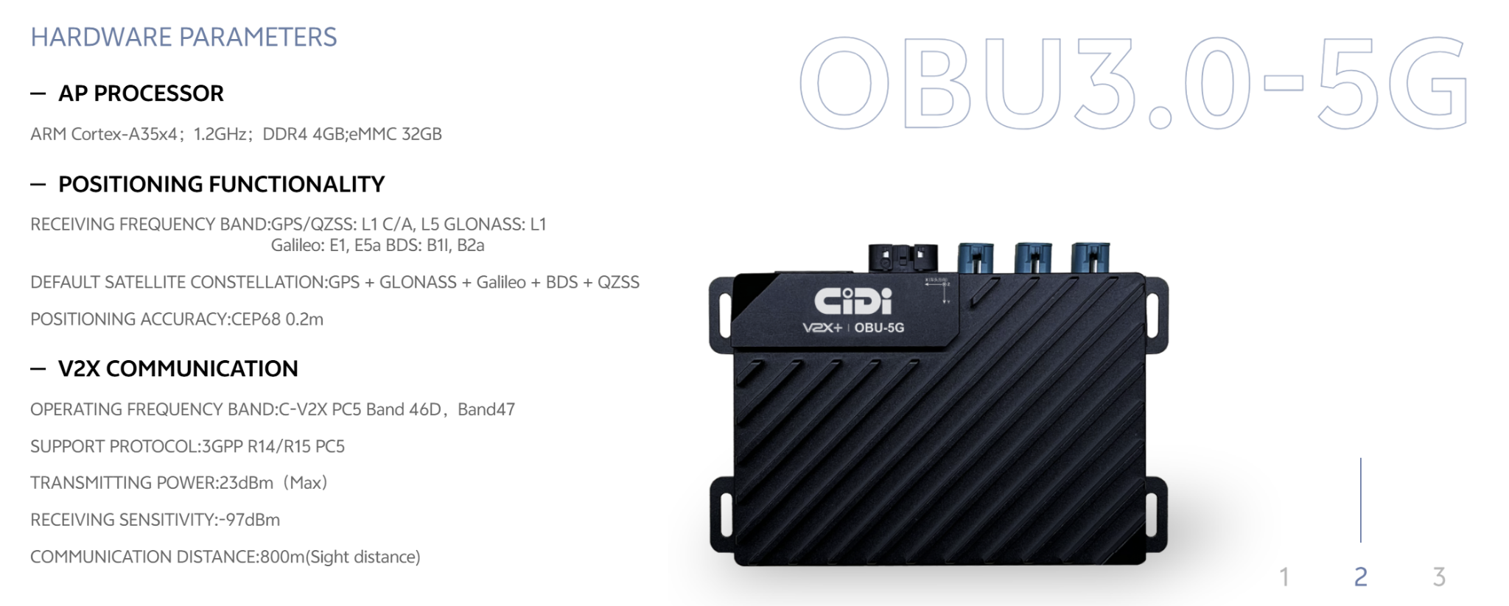

OBU-M
